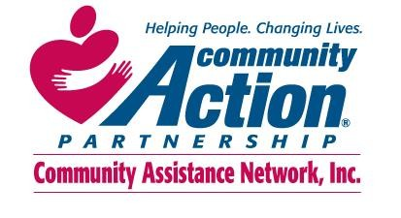
Grievance Process

Definition of a Grievance: A grievance exits when a client at any time receiving services within Community Assistance Network Inc., has a compliant or believes they may have been treated unfairly.

The purpose of the grievance process is to (a) allow clients to address both individual and program concerns in a fair, orderly, and timely manner; (b) identify problems and conflicts and resolve them with minimal disruption to the operation of assistance being received; (c) provide clients with a process that allows unresolved issues to be resolved by an unbiased higher authority.

Grievance Process

If a client would like to file a grievance against a CAN employee, they need to complete the Grievance Form which is posted throughout CAN locations and will be given at the time of request and/or can be obtained from the Community Assistance Network website https://www.canconnects.org/. Upon request, the organization will provide assistance in filling out a grievance form. If the grievance is toward a staff member, the completed grievance form should be directed to the Director of Program Operations.

The completed form should be faxed or mailed to the Director of Program Operations at the following address:
Megan Goffney
Director of Program Operations
Community Assistance Network, Inc.
7900 E. Baltimore Street
Baltimore, MD 21224
(410) 285-4674 ext. 305
Fax: (410) 285-6707
Email:
mgoffney@canconnects.org

The grievance should be filed within three business days from when the issue occurred. The Director of Program Operations must investigate the grievance with a face-to-face conference with the individual and respond, in writing (a) via notation the client’s file and/or (b) by telephone with the resident within five business days of receiving the complaint. Administrative Officer of the organization must review the compliant once received from the Director of Program Operations to maintain maximum objectivity.

The client has the right to appeal the Director’s decision within three business days to CAN’s Executive Director, Mitchell Posner at 410-285-4674 ext. 117 or by mail at the address listed above, who must respond in writing to the appeal within five business days. The written response will be copied and added to the client’s file.

If the client is still not satisfied with that decision, he/she may appeal within three business days to CAN’s Board President. The Board President Keith Shapiro will respond to the client in writing within ten business days. All decisions, at this level, are final.

All clients’ appeals must be in writing. Failure to appeal in the prescribed time frame, at any step, constitutes decision acceptance by the client. Client should be assured that the use of this policy is their right as a client. CAN will ensure that no form of retaliation is imposed upon any individual as a consequence of expressing a grievance.

